Information for Applicants
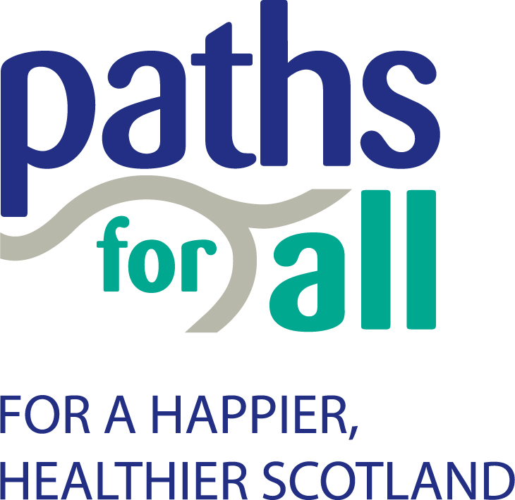

Introduction
Thank you for expressing an interest in a position within Paths for All (PFA). Our recruitment process aims to attract quality applicants and above all to recruit the right people. This document contains information about PFA, our recruitment process and our employment terms and conditions, which you may find useful.

Please note that if you do not hear from us within 2 weeks of the closing date, your application has been unsuccessful on this occasion.

About PFA
PFA aims to significantly increase the number of people who choose to walk in Scotland - whether that's leisure walking or active-choice walking to work, school or shops. We want to create a happier, healthier Scotland, where increased physical activity improves quality of life and wellbeing for all. We work to create more opportunities and better environments not just for walking, but also for cycling and other activities, to help make Scotland a more active, more prosperous, greener country.

PFA was founded as a Scottish charity in 1996 and is a partnership of twenty-eight national organisations.

PFA’s key funders are the Scottish Government Active Scotland Directorate and Transport Scotland.

More background information on the organisation, including a full list of our Partners, is available on our website www.pathsforall.org.uk.

PFA Office
The main office is within the Charity Hub, Forthside, Stirling. Our staff team covers the whole of Scotland.

Equal Opportunities
PFA supports, implements and promotes the principles and values of equal opportunities for everyone. We welcome working in a multi-cultural, multi-faith society and believe that no one should be unfairly treated.

It is the policy of PFA to ensure that no job applicant or employee receives less favourable treatment on the grounds of gender, race, marital status, disability, age, part-time or temporary status, sexual orientation or religion, or is disadvantaged by conditions or requirements that cannot be shown to be justifiable. PFA recognises the great benefits in having a diverse workforce employed solely on ability, and the application of recruitment, training and promotion policies to all individuals will be on the basis of job requirements and the individual’s ability and merits.

We also believe that staff who feel isolated, excluded or think they have been treated unfairly should have support and redress through the organisation’s policies and procedures for grievances, discipline and dealing with harassment.

Applying for a job at PFA
As part of PFA’s equal opportunities policy we want to ensure that every applicant is treated fairly. The only information that is used to decide whether or not to shortlist an applicant is the information provided in your application form. If you already work for PFA, we still require the same range of information in relation to the job you are applying for.

The job description and person specification
Every post advertised by PFA is supported by a job description and person specification. The job description outlines the main duties of the post, and the person specification describes the knowledge, experience and skills required for the position. If, after reading the job description, you are still interested in the job, then consider whether you have the relevant skills and experience, as detailed in the person specification. If you do, consider how best to demonstrate this and within your application form make sure that you give enough detail about how you meet each of the criteria.

Completing the application form
Applications should be submitted on the PFA application form. Please note that a CV is not acceptable.

The form consists of ten sections (outlined below) and should be completed in black ink or typed, as it will be photocopied.

The post
Please mark clearly what post you are applying for, including the location that you are applying for. It is also helpful for us to know where you saw the advertisement in order that we can gauge the effectiveness of our advertising media.

Personal information
You must complete this section accurately as the information you provide here helps us to comply with the Asylum and Immigration Act 1996. We are unable to offer employment to someone who does not have the right to live and work in the UK. If you are offered the post, it is conditional on you providing proof of this right through documentation such as a national insurance number, P45 or passport.

References
All appointments are subject to satisfactory references, which we will request if you are offered the post. Your two referees should represent your present or most recent employer and a previous employer, and you should provide details of the person(s) most able to confirm your suitability for the post for which you are applying. PFA reserves the right to contact any other past employers where it seems necessary. If you have not worked in paid employment, you may provide the name and address of anyone who knows you well and who will be able to confirm the information you have provided and comment on your suitability for the post.

Education, professional qualifications and training
The person specification sets out any qualifications required for the job, and you should list these in this section. You may also want to include any other qualifications you possess or training courses you have attended that you feel are relevant for the post. If you are offered the post, we will need to view the qualification certificates that you list.

Employment history
In this section, you should provide details of your past employment, starting with the most recent job and accounting for any periods of time not spent in further education or employment. Information supplied should include the main features of your role, including specific responsibilities.

Other information
This section of the application form is very important. Use it to demonstrate how your knowledge, experience and skills match the job description and selection criteria listed in the person specification. If necessary, you can continue on an additional sheet as indicated on the application form.

Data Protection
All information supplied on application forms will be kept strictly confidential and will only be used for the purpose of recruitment selection. Application forms for all applicants will be retained in a secure area for a period of one year from the date of interview and then destroyed.

Interviews
The interview date is usually stated in the advertisement. If the date set presents a problem, please email the recruitment team as soon as possible, however our ability to accommodate changes to the timetable may be limited.

Benefits and terms of employment
PFA has a comprehensive set of employment policies, procedures and guidelines that enable us to operate effectively and fairly with our employees.

Annual Leave
Annual leave entitlement for all full-time staff is 25 days per annum, plus 11 statutory holidays, 4 of which are fixed and must be taken at Christmas and New Year. The 7 remaining statutory days are flexible. Holidays for part time staff are pro-rata. PFA also offers attractive maternity, maternity support, adoption and special leave policies.

Flexible working
A flexi-time policy is in place to enable employees to balance their work and home responsibilities.

Pension

PFA is required to enrol all staff in a workplace pension scheme. Our pension provision is 10% employer contribution and 6% employee contribution.

Expenses
Staff expenses are reimbursed on a monthly basis in arrears and an expenses float is made available at the start of employment if required by the post.

Cycle to Work Scheme
PFA offers a salary sacrifice scheme to assist staff in the purchase of cycles and associated cycling equipment.

Car breakdown cover
All staff can take advantage of car breakdown cover supplied through a national organisation.

Training and development

It is our aim to provide opportunities for all employees to learn and develop within PFA. We are committed to providing high-quality training and development that is relevant to the job holder and the organisation, and work with employees and managers to identify learning needs.

Probationary period
All new employees must serve a probationary period, normally of six months. During this time an employee must demonstrate competence for appointment to the post.

Appraisal and performance reviews
We are committed to maximising the skills and potential of all employees in support of our strategic aims and objectives. A key aspect of this process involves employees participating in regular one-to-one sessions and an annual performance and development review.

Sick pay
We offer up to a maximum, in any period of twelve months, of 12 weeks at full pay, followed by 12 weeks at half pay for long term sick leave.

Health and Safety
Where the job description includes out of office working a mobile phone will be offered to employees. PFA retains the services of a Health and Safety Adviser.

Recruitment complaints procedure
Applicants for posts in PFA will be selected on their ability to fulfil the requirements of the post applied for, based on the guidelines in our Recruitment and Selection policy. If you consider that the recruitment process has been managed in a discriminatory or unfair manner, or if there is any aspect of our process that did not comply with our standards, you may register a complaint with the Chief Executive Officer. All complaints must be in writing.

Paths for All, June 2024

