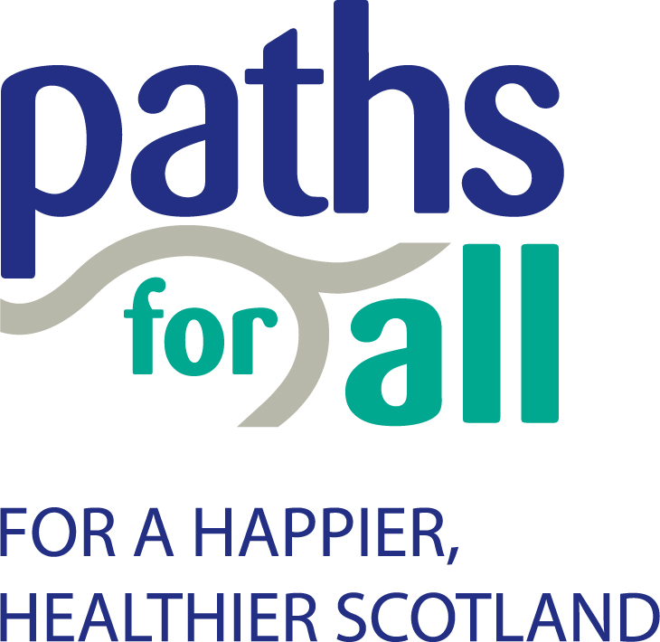

Private and confidential

Recruitment Monitoring Form

Paths for All Partnership is committed to the provision of, and the removal of barriers to, equal opportunity in employment. As a reasonable employer, it undertakes to conduct its affairs in a manner which will not discriminate against, either directly or indirectly, any employee, job applicant or volunteer, on the grounds of: disability; gender; race; religion or belief; age; sex; sexual orientation; marital or civil partnership status; or pregnancy and maternity.

To help us meet this commitment, it would be helpful if you would complete this form. This monitoring form will be separated from your application on receipt and those involved in the selection process will not see it. The information you give will be used solely for monitoring purposes.

Age Range: | 16-24  35-44  55-64 |  | 25-34  45-54  65+
Sex: | Female  Intersex  Prefer not to say |  | Male  Non-binary

I would describe myself as:
Ethnic Origin: | White British  White Irish  Gypsy or Irish Traveller  White other
Black/Black British
Asian British
Asian
 | Chinese  Mixed  Arab  Any other:  Prefer not to say |  | _____________________
I would describe myself as:
Religion or belief: | Agnostic  Atheist  Bah’ai
Buddhist
Christian
Hindu
 | Humanist  Jewish  Muslim  Pagan  Sikh  Rastafarian  Scientologist  Shinto  Zoroastrian  No religion or belief  Prefer not to say  Any other: |  | _____________________
Disability:  Do you consider yourself to have a disability? *  *The Equality Act 2010 defines disability as “a physical or mental impairment that has substantial and long term adverse effect on a person’s ability to carry out normal day to day activities”. |  | Yes |  | No
If yes, please specify:

Hearing impairment
Visual impairment
Speech impairment
Mobility impairment
Physical co-ordination difficulties
Reduced physical capacity
Learning difficulties
Mental ill health
Progressive conditions
Other Please specify …………………………………………………………….

The Equality Act 2010 requires all employers to make reasonable adjustments for disabled employees

Wherever possible Paths for All aims to remove barriers that get in the way of a disabled person from doing their job. Should you be successful in your appointment to the post, do you require any reasonable adjustments to be put in place?

Please specify below:

Marital Status: | Married  Separated  Widowed  Civil Partnership  Prefer not to say |  | Single  Divorced  Other: | ____________
Sexual Orientation
Bi-sexual |  | Gay Woman/ Lesbian
Gay Man |  | Heterosexual/ Straight
Other |  | Prefer not to say

Please state where you first learned of this vacancy

Name of publication:
Website name/organisation:
Jobcentre Word of Mouth
Other (please state)

Post applied for:

Thank you for your co-operation. Please return this form with your application.

Paths for All, June 2021

